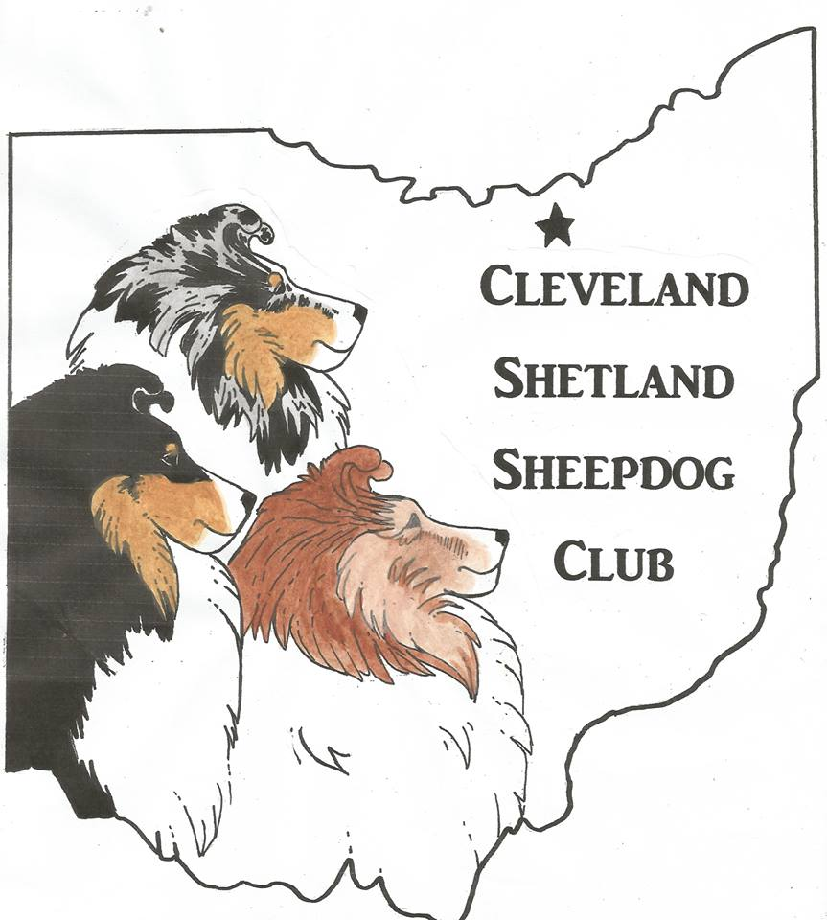

Cleveland Shetland Sheepdog Club

*S P O T L I G H T*

December, 2018

Merry Christmas!

**Editor:** Sue Moreland ([bravoshelties@frontier.com](mailto:bravoshelties@frontier.com))

**Club Officers** (term ending at our Annual Meeting, October 2020)

**President –** Barbara Kaplan ([barbkaplandtm@yahoo.com](mailto:barbkaplandtm@yahoo.com))

**Vice- President –** Laura Chegan ([lchegan@att.net](mailto:lchegan@att.net))

**Treasurer –** Rhadine Zabrecky ([rayzabrecky@gmail.com](mailto:rayzabrecky@gmail.com))

**Recording Secretary –** Kristie Mariner ([kristiekuhls@gmail.com](mailto:kristiekuhls@gmail.com))

**Corresponding Secretary** – Sue Moreland ([bravoshelties@frontier.com](mailto:bravoshelties@frontier.com))

**Board Members** (term ending at our Annual Meeting, October, 2019)

John Bush ([jbushes@juno.com](mailto:jbushes@juno.com))

Cheryl Sacerich ([CnUk9@cs.com)](mailto:CnUk9@cs.com))

Barb Schmauder ([machowder@gmail.com](mailto:machowder@gmail.com))

**Sheltie Rescue (NEOSSR) (Website: http://www.neossr.org/)**

**President –** Cindy Hazelett 330-296-8257 ([sheltiequeen1@yahoo.com](mailto:sheltiequeen1@yahoo.com))

**Vice-President –** Paula Adams 330-650-4846 ([PXAdams@aol.com](mailto:PXAdams@aol.com))

*Send donations (payable to North East Ohio Sheltie Rescue), to:*

*Dori Mueller, 41753 Blanche Avenue, Elyria, Ohio 44035*

***TO ADVERTISE IN THIS NEWSLETTER, contact Sue Moreland***

**MEETINGS ARE HELD** on the second Tuesday of every month (unless the dates of the Crown Classic necessitate a change). The regular meetings begin promptly at 7 o’clock p.m. and are open to anyone with an interest in all things concerning Shelties.

NEXT GATHERING: TUESDAY, December 13, 2018

NOT a general meeting. This will be our annual Christmas Party and will be held at the Brown Derby, Bagley Road, Middleburg Hts., across from the hospital. We will begin to assemble around 5:30-6:00.

Reservations MUST be called in to Chris, 612-578-3124

@CLEVELAND ALL-BREED TRAINING CLUB

210 Hayes Drive, Brooklyn Heights, OH 44131

(if you need directions, contact Barb Kaplan)

j0424820

December’s meeting will be a dinner at the Brown Derby provided by CSSC see page_____

**Coming 2018 Events (Mark your calendars):**

**A calendar of events for 2019 will be in the January newsletter**

***You are Invited!! CHRISTMAS PARTY (in lieu of regular meeting) December 11, 2018***

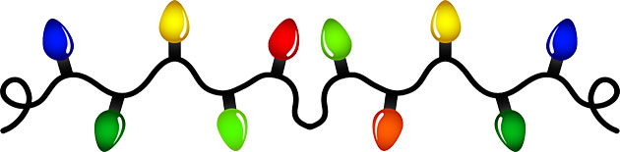

***WHERE: Brown Derby Restaurant 18332 Bagley Road, Middleburg Hts., Oh 44130***

***WHEN: Tuesday, December 11, 2018***

***WHY: Well, why not?***

***TIME: social time 5:30 p.m.- ?, dinner when all have arrived***

***We hope you will join us, but we need to have a body count. Please RSVP to Chris Cammarn (***[***cardcammarn@gmail.com***](mailto:cardcammarn@gmail.com)***) or 612-578-3124. There will be no cost to our members for the dinner, and of course you may bring your spouse. Alcoholic beverages and appetizers are available but not included.***

**CSSC CLUB DUES**

**ARE DUE BY JAN. 01**

You will be receiving a dues notice form by separate e–mail. If you do NOT, please notify Sue Moreland …. [bravoshelties@frontier.com](mailto:bravoshelties@frontier.com)



**CLEVELAND SHETLAND SHEEPDOG CLUB**

**GENERAL MEETING**

**Notes from the meeting which took place Tuesday, November 13, 2018**



**President’s Report** – President Barb called the meeting to order at 7:01 p.m. Other members present this evening were Kristie Mariner, Steve Mariner, Kim Furlong, Mary Thrall, Chris Cammarn, Barb Kaplan, John Bush, Rhadine Zabrecky, Suzanne Stachurski and Laura Chegan. Our guests were Emily Burrier and Cindy Bunner.

**Recording Secretary’s Report** -- Steve moved and Chris seconded that the minutes of the last meeting be approved as they were published in the October newsletter.

**Corresponding Secretary’s Report:** (as Sue could not attend, her reports were e-mailed to Kristie)

* Oct. 15 Letter sent to Fulton County asking permission to hold our specialties on their weekend again in 2019. Suzy said we will hear back from them after their upcoming meeting.
* Oct. 17 from AKC Event Operations announcing changes made recently by the Board of Directors: (1) effective 1/1/19, clubs will be allowed to limit their entries by either the total number of dogs or total entries. If a club needs to limit their event, please call your AKC Event Operations representative. (2) effective 12/1/18 the definition of “immediate family members” (Rules Applying to Dog Shows Chapter 11 Section 13) will now include domestic partners, grandparents, and grandchildren and the corresponding adopted, step- and half-relations.
* Oct. 20 From AKC, closeout notices for our October specialties, which include events #2018084808, 09 and 10 with corresponding numbers for next year (Sue has) which will take place October 5 and 6, 2019.
* Oct. 24 Event pending notice from AKC for our Agility Trial scheduled to take place July 12, 2019
* Oct. 29 Processing has completed for July 12, 2019 by Fran Dacek. The number assigned to this event is 2019084807.
* Nov. 1 From AKC, thank you for updating your membership list.
* Nov. 2 From NEOSSR, announcing their Holiday Auction beginning today, November 13. Donations are welcome. Contact [candleladypamela@gmail.com](mailto:candleladypamela@gmail.com)
* We received thank you cards from some of the participants of our 2018 Specialties.

**Report of the Treasurer:** As always, a complete financial report will be made available to any member upon request.

**Reports of the Committees:**

**SPECIALTY 2018** – Kim reported that the InfoDog oversight did cost us entries. InfoDog suggests we get them the Premium List by July. Kim received many great compliments about the specialty weekend and is already looking forward to 2019!

**SPECIALTY 2019 –** Sue has application paperwork nearly ready to send in to apply for our 2019 specialty weekend but needed the following information confirmed, which was part of the business tonight: Barb Kaplan will be Show Secretary for the three specialty shows AND the two rally trials. There will not be a separate chairperson to oversee the rally trial. Barb is working on the Judging Panel for rally. We will be accepting mixed breeds. We will be limiting entries for rally. We are not offering NOHS or Junior Showmanship. We do want to offer the 4-6 month puppy competition. JUDGES: we have contacted 5 judges for the conformation shows, and all 5 have tentatively accepted at this point. They are: Joann Avery and Mary Lou Herman coming back for Sweepstakes, Mr. John Buddie, Ms. Jennie Tomlin Hynes and Ms. Deborah Wyman. 2019 DEADLINES: application date for both events including the judging panel will be at least 18 weeks before the closing date, or Wednesday, May 15. Premium List deadline for both events will be at least 5 weeks before the event dates, or August 31. At this time, two (2) copies must be sent to AKC. Closing date for both events will be 16 days before the events, or Wednesday, September 18.

**WEB SITE** Steve needs to get passwords, etc. from Betty and will work on upgrading the site.

**Unfinished Business:**

**ELIGIBILITY –** Sue reported that our AKC eligibility has been completed (to hold our) specialties in 2019.

**SOFTWARE –** Barb needs software for our specialties, and reported that it will cost $250. Kim moved that we go ahead and purchase, Chris seconded.

**New Business:** Tabled for tonight, but these issues will be on the agenda for the January meeting: Steve will report on the webinar “How to Put on a Dog Show.” Rhadine will be collecting dues. Suzy will bring up the topic of offering MDR1 mutation testing at our 2019 specialties. Chris will bring up the Cheryl Anderson seminar idea.

Suzy motioned and Chris seconded that we donate $100 to the AKC Humane Fund to help victims of abuse/violence or other causes of home loss which involved pets. Motion carried. We need to donate to NEOSSR. Cindy Bunner requests a membership application. Sue will send.

**BRAGS:**

Our guest this evening, **Emily**, received her first leg in novice obedience with her 18-month old “Sophie.” Bravo!

**There being no further business, Suzy moved and Steve seconded that the meeting be adjourned at 7:52 p.m. Board Meeting to follow.**

Board Meeting convened at 8:26 p.m. Our list of things needing to be done include the following: updating membership requirements, updating job descriptions and standing rules, and putting together a yearly calendar with all event dates, deadlines, etc. We need to find out how much and when we need a deposit to CABTC to rent the building for the 2019 specialties. Meeting adjourned 8:35 p.m.



"Walkin' in A Doggie Wonderland"

Dogs tags ring, are you listening'?   
In the lane, snow is glistening'.   
It's yellow, NOT white - I've been there tonight,   
Marking up my winter wonderland.

Smell that tree? That's my fragrance.   
It's a sign for wand'ring vagrants;   
"Avoid where I pee, it's MY property!   
Marking up my winter wonderland."

In the meadow Dad will build a snowman,   
Following the classical design.   
Then I'll lift my leg and let it go, Man,   
So all the world will know it's mine-mine-mine!

Straight from me to the fencepost,   
Flows my natural incense boast;   
"Stay off of my TURF, this small piece of earth,   
I mark it as my winter wonderland."

### Share These Rules With Your Dog at Christmas Time

Be especially patient with your humans during this time. They may appear to be more stressed-out than usual. They may come home with large bags of things they call gifts. Do not assume that all the gifts are yours. Be tolerant if your humans put decorations on you.  They seem to get some special kind of pleasure out of seeing how dogs look with fake antlers.  Crazy.

**The Christmas Tree:**They may bring a large tree into the house and set it up in a prominent place and cover it with lights and decorations.  Bizarre as this may seem to you, it is an important ritual for your humans, so here are some things canines need to know:

**[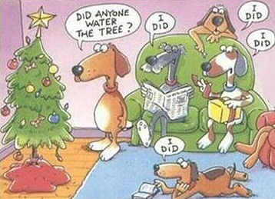](http://www.guy-sports.com/funny/shaggy_dog_stories.htm)**

* Don't pee on the tree.
* Don't drink water in the container that holds the tree.
* Mind your tail when you are near the tree.
* If there are packages under the tree, even ones that smell interesting or that have your name on them, don't rip them open.
* Don't chew on the cord that runs from the funny-looking hole in the wall to the tree.

**Discretion**Your humans may occasionally invite lots of strangers to come visit during this season. These parties can be lots of fun, but they also call for some discretion on the part of us dogs:

* Not all strangers appreciate kisses.
* Do not eat off the buffet table.
* Beg for goodies by all means but do it........ subtly.
* Be pleasant, even if unknowing strangers sit on your sofa.
* Don't drink out of glasses that are left within your reach.

Preparing Your Dog for Holiday Guests

[Mychelle Blake, MSW, CDBC, Lifestyle Contributor and Pet Behavior Expert](http://www.pethealthnetwork.com/pet-news/our-experts/mychelle-blake-msw-cdbc-lifestyle-contributor-and-pet-behavior-expert)

[**Dog Behavior**](http://www.pethealthnetwork.com/dog-health/dog-behavior)

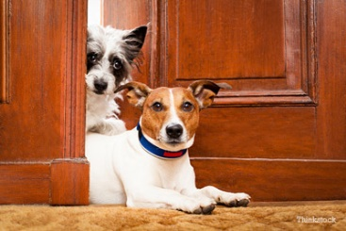With the [holidays](http://www.pethealthnetwork.com/tags/holidays) coming up, your home is likely to be experiencing more activity and guests. Depending on your dog’s personality and habits, this can be a difficult time for both your dog and your family. Planning ahead and doing some simple [training](http://www.pethealthnetwork.com/tags/training) with your dog can make this a more pleasant experience for everyone.  
  
**Training before the holidays**  
If you haven’t taught your dog any basic manners or [behaviors](http://www.pethealthnetwork.com/tags/behavior), now’s the time to start! Even if you’re short on time, you can easily work in short training sessions a few times a day and see results quickly. Work the training into your daily life as much as you can, such as training “stays” while you are cooking in the kitchen, or asking the dog for “sits” and “downs” while you’re on the couch watching TV. The more you ask for behaviors as part of your routine, the more your dog will develop using them as a regular habit. Some of the behaviors that can be most useful during the holidays are:  
  
**Sit/Stay –** Sit (and stay) is an extremely versatile behavior. You can use it to teach the dog not to jump on visitors at the door, to sit and allow people to greet him, to stay in one place comfortably while you move about the house, and much more. Train your dog to sit and stay in the places he’s most likely to jump up, such as just inside and outside of the front door, in and out of the car, by your kitchen, living room area, or by the back door. Once your dog is doing well, invite friends and neighbors over to practice his sit/stay so he’ll be sitting like a champ when your guests arrive for dinner**!**  
  
**Go to your place –** This is also a wonderful command for [dogs](http://www.pethealthnetwork.com/tags/dogs) that are more boisterous or bother guests at the dinner table or in the living room. Give your dog a place that is “his.” Usually we use a dog bed or mat, or you can use crates as I do with my dogs. Bring your dog to the mat, bed or crate and reward him for being there and laying down/going inside; pair it with a word such as “place” or “crate.” As with the sit/stay, move up to practicing this one with friends and neighbors so the dog has the behavior solid by the time guests will be arriving. Since you want this to be a good experience for your dog, you can give him a nice treat to chew on while he lies on the bed or in their crate. Examples might include a food stuffed toy, a chew stick or something else that your dog loves and can quietly enjoy.  
  
**Leave it –** Leave it is an indispensable behavior during the holidays. Not only can you use it if the dog decides to go for a [delectable human treat on the dining room table](http://www.pethealthnetwork.com/dog-health/dog-checkups-preventive-care/thanksgiving-holiday-dangers-avoid), you can also use it on things that dogs are attracted to, such as shiny holiday decorations, holiday plants, and wrapped gifts. Leave it can be generalized to anything once you’ve taught it with [food](http://www.pethealthnetwork.com/tags/food) and can help you to tell the dog to move away from something even if you’re at a distance. Another behavior that is often paired with leave it is “drop it” which basically tells the dog to drop an item in their mouths, which is helpful if the dog has grabbed something before you had a chance to use leave it.  
  
**Tricks –** Okay, while this may not seem like an important behavior, tricks can be a great thing to teach your dog because it gives him something to do. If you have guests coming over who may be a bit nervous about your dog, even if he is friendly, tricks can be a great way to “break the ice.” A dog seems less intimidating when he can shake, high five, spin, roll over or do something equally adorable. If your guests include children, they will most likely be delighted by these behaviors and may even want to teach the dog some themselves, which can be a fun holiday activity (with adult supervision, of course!)

**Management during the holidays**  
The second part of an effective set up for your dog during the holidays is good management:   
  
**Keep your dog comfortable—** If you know your dog doesn’t care for guests, have a crate ready for him in a quiet spot, such as bedroom with a closed door. Alternatively, keep him in a place where he can feel comfortable and not interact with guests, such as a bedroom, laundry room or other area that is closed off with a door or baby gate. Never allow people to interact with your dog if the dog isn’t comfortable, as this can increase the anxiety he is feeling.  
  
**Provide distractions—** Have a variety of items ready for your dog, to occupy his time, while you visit with your guests. This can include food stuffed toys or puzzles, bones, chews, chew sticks and [toys](http://www.pethealthnetwork.com/tags/toys). Always give your dog an item such as this in a safe place and supervise any interaction if children will be visiting.   
  
**Exercise, exercise, exercise—** You cannot [exercise](http://www.pethealthnetwork.com/tags/exercise) your dog enough during these busy times. As the saying goes, “A good dog is a tired dog.” The more physical exercise your dog gets, the less rambunctious when people come to visit, and there’s a good chance after greeting guests he’ll be more than happy to crawl up on his bed or crate and take a nap.  
  
If you find you need help with training the behaviors we’ve discussed, you can find professionals near you who can help at [www.iaabc.com](http://www.iaabc.com/), [www.petprofessionalguild.com](http://www.petprofessionalguild.com/) and [www.apdt.com](http://www.apdt.com/).



*and dogs . . . . . . .*

*It’s A Dog’s Life: A Christmas Tale*: An Original Short Story

*by Gail Farrelly*

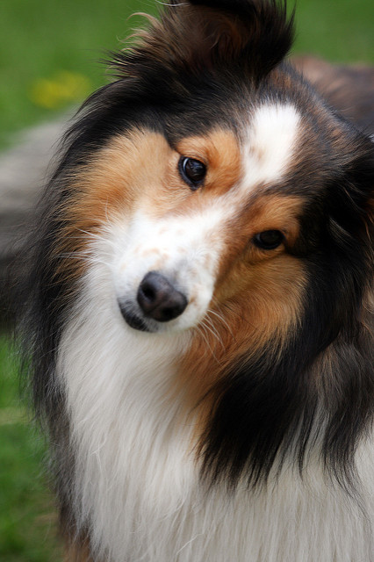Two big eyes peered out from a little face. The little Sheltie rested in the grass beneath the bench on which his master, an old man with a cane, was sitting. “Miss,” the man said, “would you do me a favor and walk my dog around the lake? I have to rest my old bones today.

”The woman wanted to say “No, my 40-year-old bones are pretty weary too.” They had been weary every day for the past year, since last September when her husband had been killed in a car collision. But then there were those two deep, doggy eyes watchfully waiting. Grudgingly, she accepted the leash that was extended to her. The dog leaped up in eager anticipation, as if he’d just been released from prison. He charged ahead with gusto. Soon the DOG was taking the woman for a walk, rather than vice versa. The woman was puffing by the time they had circled the Bronxville Lake and returned to the “starting” bench. There was only one problem; no sign of the dog’s owner. She searched and searched to no avail. No one in the park remembered the man.

She went to the police station and reported the incident. There was no report of a man of his description missing. The police checked hospitals and even the morgue. Still no sign of the old man.

“What am I supposed to do with HIM?” she asked, pointing an accusing finger at the little dog parked at her feet.

“Well, you could bring him to the pound,” the policeman said.

“Good idea,” she answered.

The officer continued: “These days the pound is pretty crowded, though.”

She shrugged. But when she looked down, there were those two soulful eyes peering up at her; and so she said, “I guess I could bring him home for a day or two.”

A day or two stretched into a week, which soon stretched into a month, then two, then three. The woman and dog often went for brisk walks around the lake, but there was no sign of the old man. The woman’s life changed considerably. Having to get up early to walk the dog, she could no longer sleep late. Since she had to feed the dog several times a day, she got back into the habit of eating three meals a day, a habit broken since her husband died. The dog ripped up some of her old clothes and she had to shop for new ones, the first new clothes she had bought in over a year. She needed them because she had met some new friends (fellow dog walkers) and had begun to socialize again.

On Christmas Eve, the dog seemed restless as he and the woman circled the Bronxville Lake. He stopped and stared at each person they passed. Several times he scampered into the woods surrounding the lake, sniffing and darting his eyes around at anything and everything. He appeared to be on a search mission.

The woman thought it was strange because the dog’s mood seemed to be in sharp contrast with her own. She was feeling so much more peaceful these days. She bent down and patted the little dog, trying to calm him down and she mumbled, “He never even told me your name.”

They stopped for a rest at the bench where it had all begun three months ago. The dog began barking and sniffing at a small scrap of paper stuck to the bench. The woman picked it up and was startled to read “His name is Angel.” She looked down at the dog, now resting at her feet; he, too, had found peace.

She thought about the little old man with the cane who had given her the dog. He was chubby, with red cheeks, and a long white beard. He had said he was tired, but he didn’t look it. In fact, he looked quite hale and hearty. She thought of the movie “Miracle on 34th Street.” Hmm. She questioned herself: “Am I losing it?”

She tugged at the dog’s leash and said, “Come on Angel, we’re going home.” Angel jumped to attention. She was startled to see that his eyes were gazing upward — not at her, but at something way, way above her. She followed his gaze but saw nothing.

As they headed for home, she couldn’t help but think that maybe, just maybe, 34th Street didn’t have the monopoly on Christmas miracles. There had been at least one in Bronxville. She quickened her pace. Were there more to come?

